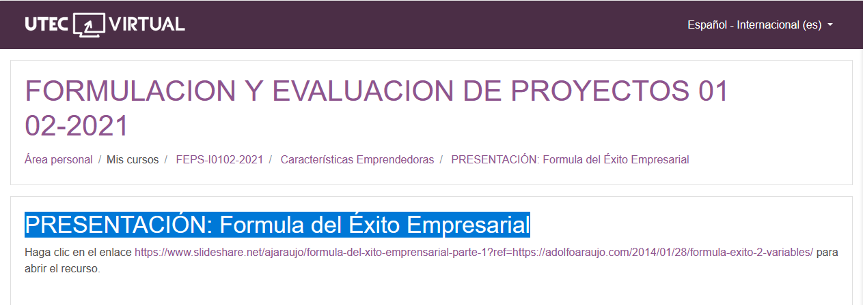

<https://www.slideshare.net/ajaraujo/formula-del-xito-emprensarial-parte-1?ref=https://adolfoaraujo.com/2014/01/28/formula-exito-2-variables/>

<https://www.slideshare.net/ajaraujo/formula-del-xito-emprensarial-parte-1?ref=https://adolfoaraujo.com/2014/01/28/formula-exito-2-variables/>